DMX Control manual
Glenn Meader gmeader@gmail.com
github.com/gmeader/ESP32-S3-TFT-Feather-DMX-Control
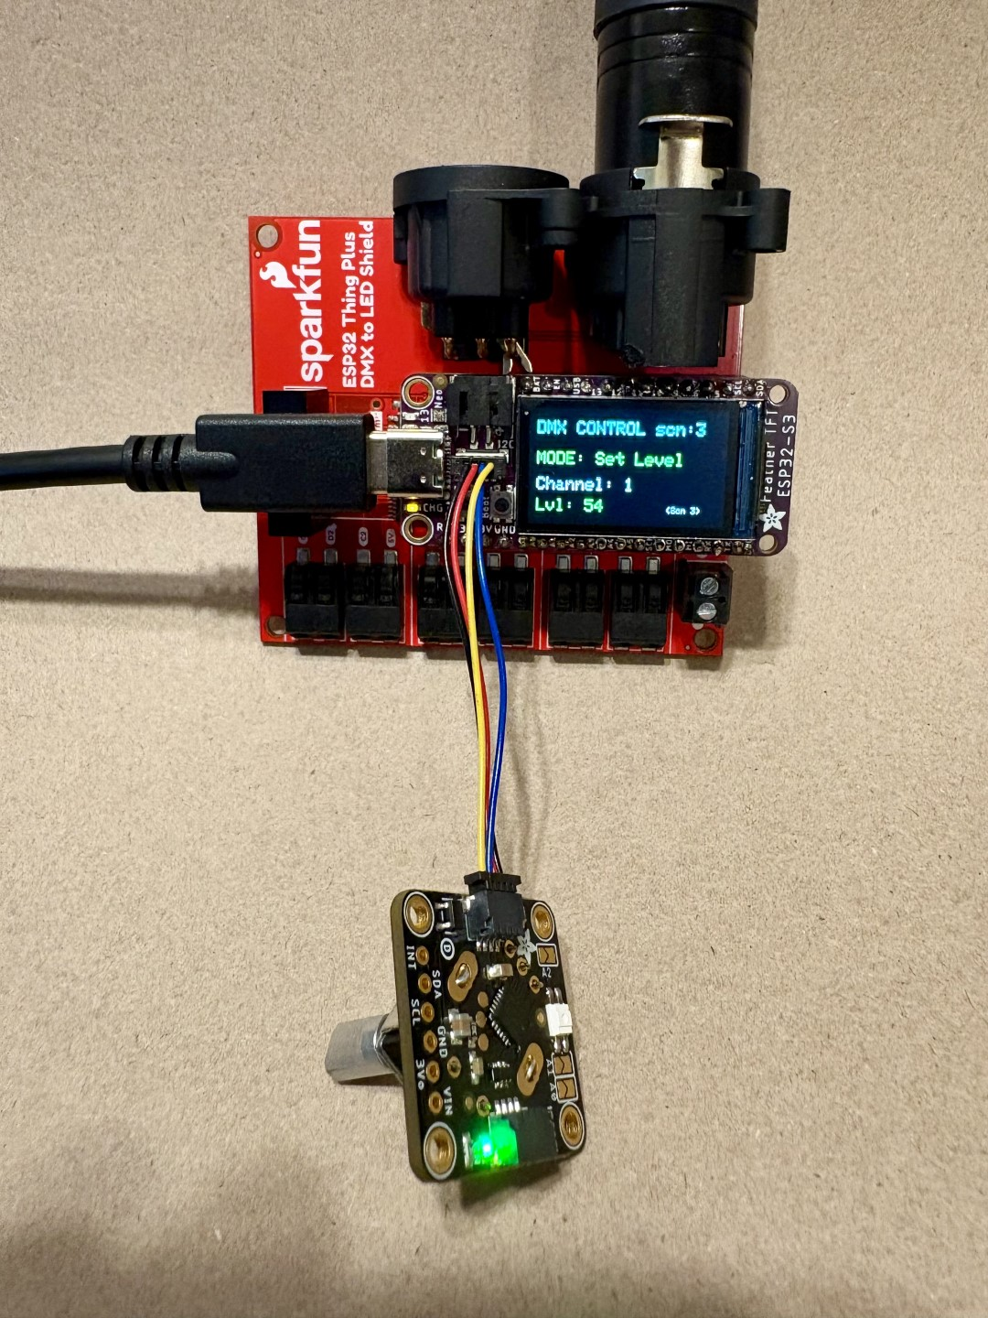
This device is an 8 scene 512 channel DMX controller. It transmits DMX out the 3-pin XLR connector. You can store 512 channels of DMX levels in each of 8 scenes. It stores the scene data in Flash so it remembers when power goes off. You can select a scene and do a timed crossfade into that scene. The fade time is stored with the scene data.
It has three parts:
1. Adafruit ESP32-S3 TFT Feather
2. Sparkfun ESP32 Thing Plus DMX to LED Shield
3. Adafruit I2C Stemma QT Rotary Encoder Breakout with Encoder

You plug these together and plug in a USB-C to power it. Upload the code to the device using a USB-C cable to a computer running the Arduino IDE.

Usage

CHANNEL_SELECT Mode: Rotating the encoder cycles through DMX channels 1 to 512. Pressing the button selects the chosen channel and switches to Set Level mode.
SET LEVEL Mode: Rotating the encoder sets that DMX channel's value to between 0 and 255. Pressing the button again stores the value in the current scene and returns you to channel selection mode.
SCENE_MANAGE Mode: You can toggle into this mode by long-pressing the encoder button (holding it for more than 1 second).
In Scene Manage mode, turning the encoder changes the active scene number from 1 to 8.
Clicking the encoder button viewing a scene number, crossfades into that scene. Double-clicking instead instantly switches to the selected scene.
To save your current live adjustments as a scene, simply click the encoder button while in SET LEVEL mode; it will automatically save to your active scene.
Crossfading: Interpolates values smoothly toward the target scene over a number of seconds. See Altering Crossfade Time.
Scene Copy/Paste: When inside SCENE_MANAGE mode: Double-click the encoder button to copy the current scene to a clipboard buffer.
Then turn the dial to select your destination scene number.
Double-click again to paste the clipboard data directly into that scene and save it to flash memory.
Altering Crossfade Time: Inside SCENE_MANAGE mode, press and hold the button for 1 second to enter DURATION_EDIT sub-mode. Spin the encoder to change the current scene's fade time (in 100ms steps). Click once to lock it and return to the scene manager.
To Move Between Modes: Hold the encoder down for 1 second. The screen will step from Channel Select ➔ Scene Manage ➔ Set Fade Rate ➔ back to Channel Select.
Commanding a Crossfade vs. Instant Snap: When choosing a scene to activate in SCENE_MANAGE mode:
Single Click: Triggers a smooth crossfade into your highlighted scene and drops you back into channel selection. A progress bar moves across the bottom of the screen.
Double Click: Snaps instantly into your highlighted scene, bypassing the progress bar, and drops you back into channel selection.
Grand Master Mode Accessible by triple-clicking the encoder button from any mode. In this mode, rotating the encoder scales a global multiplier from 0% to 100%. This downscales all outgoing DMX channel payloads linearly without modifying the values stored in your scenes.
Fade Progress Bar: When a crossfade is active, a graphical progress bar renders across the bottom of screen, showing how much time remains on the transition.

